CSC 2400 / Chapter 3 Homework B

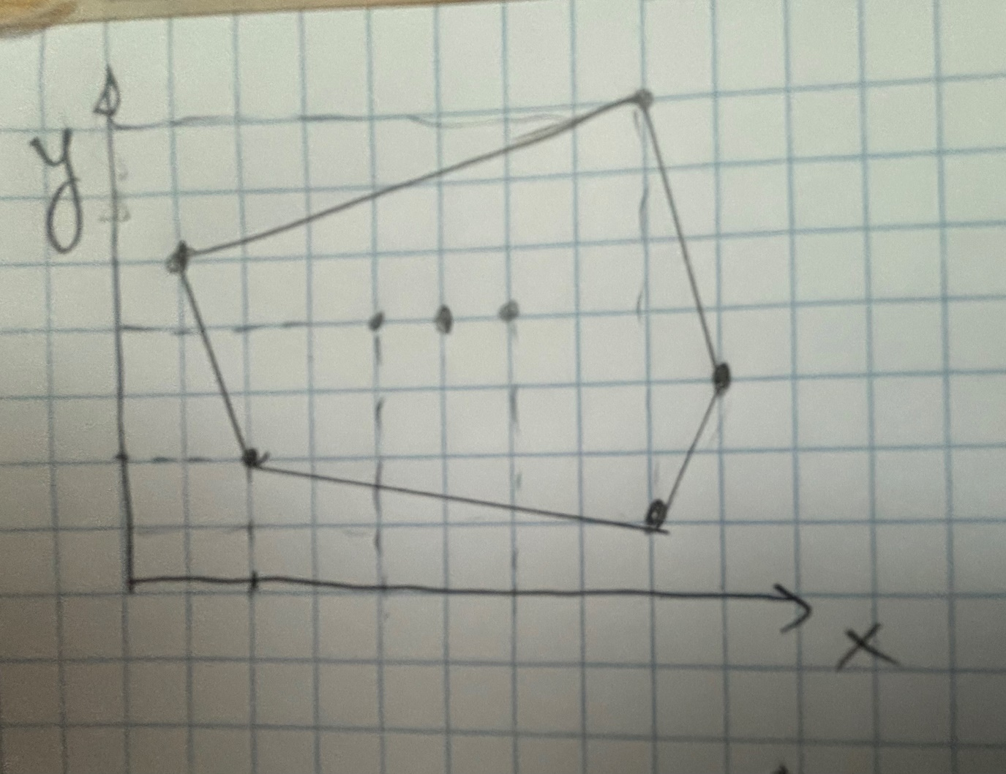

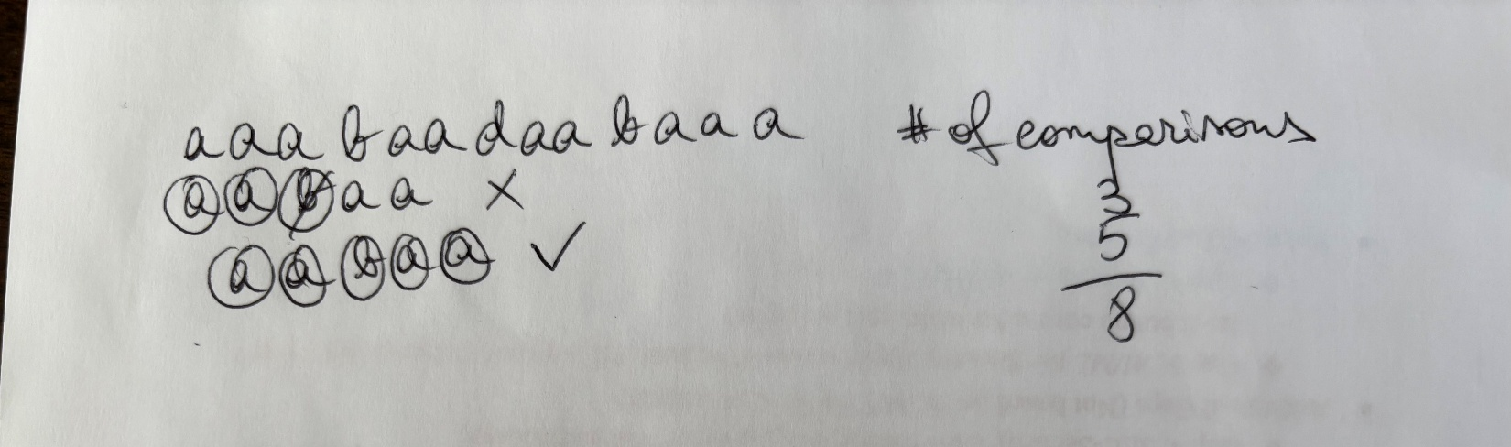

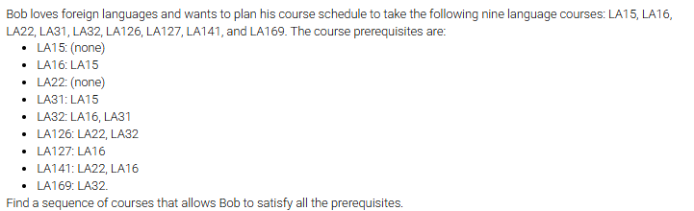
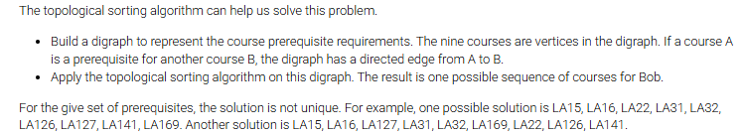
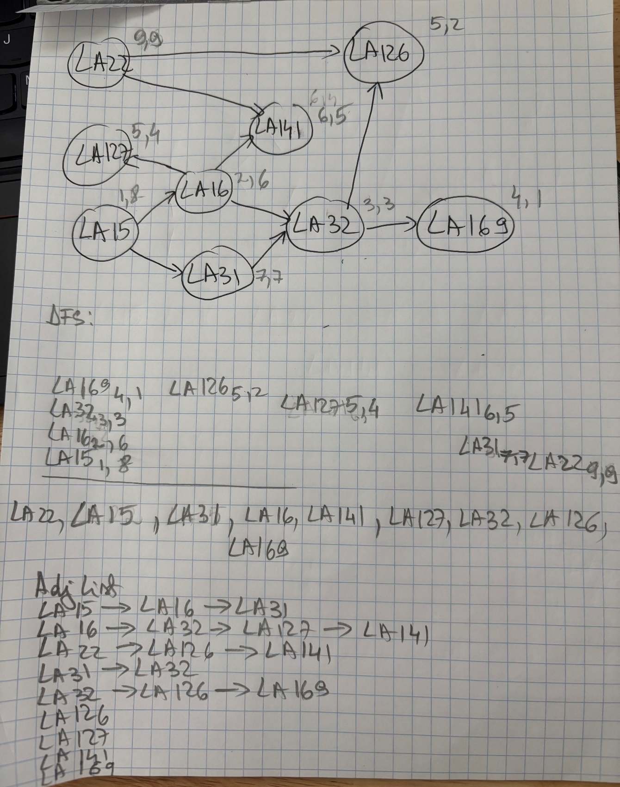
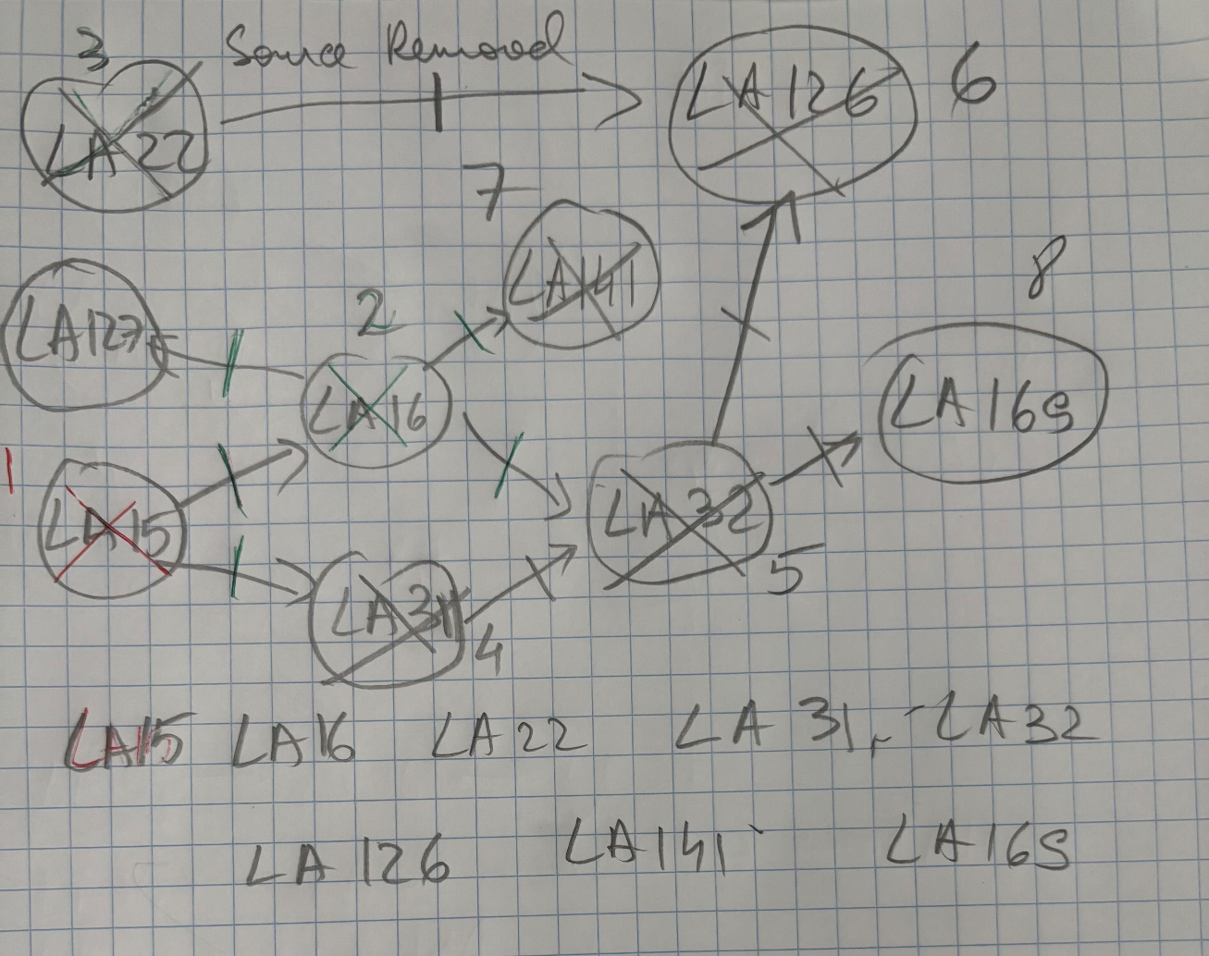

Let G be a graph whose vertices are the integers 1 through 8, and let the adjacent vertices of each vertex be given by the table below:
vertex | adjacent vertices
1 | (2, 3, 4)
2 | (1, 3, 4)
3 | (1, 2, 4)
4 | (1, 2, 3, 6)
5 | (6, 7, 8)
6 | (4, 5, 7)
7 | (5, 6, 8)
8 | (5, 7)
Assume that, in a traversal of G , the adjacent vertices of a given vertex are returned in the same order as they are listed in the above table.

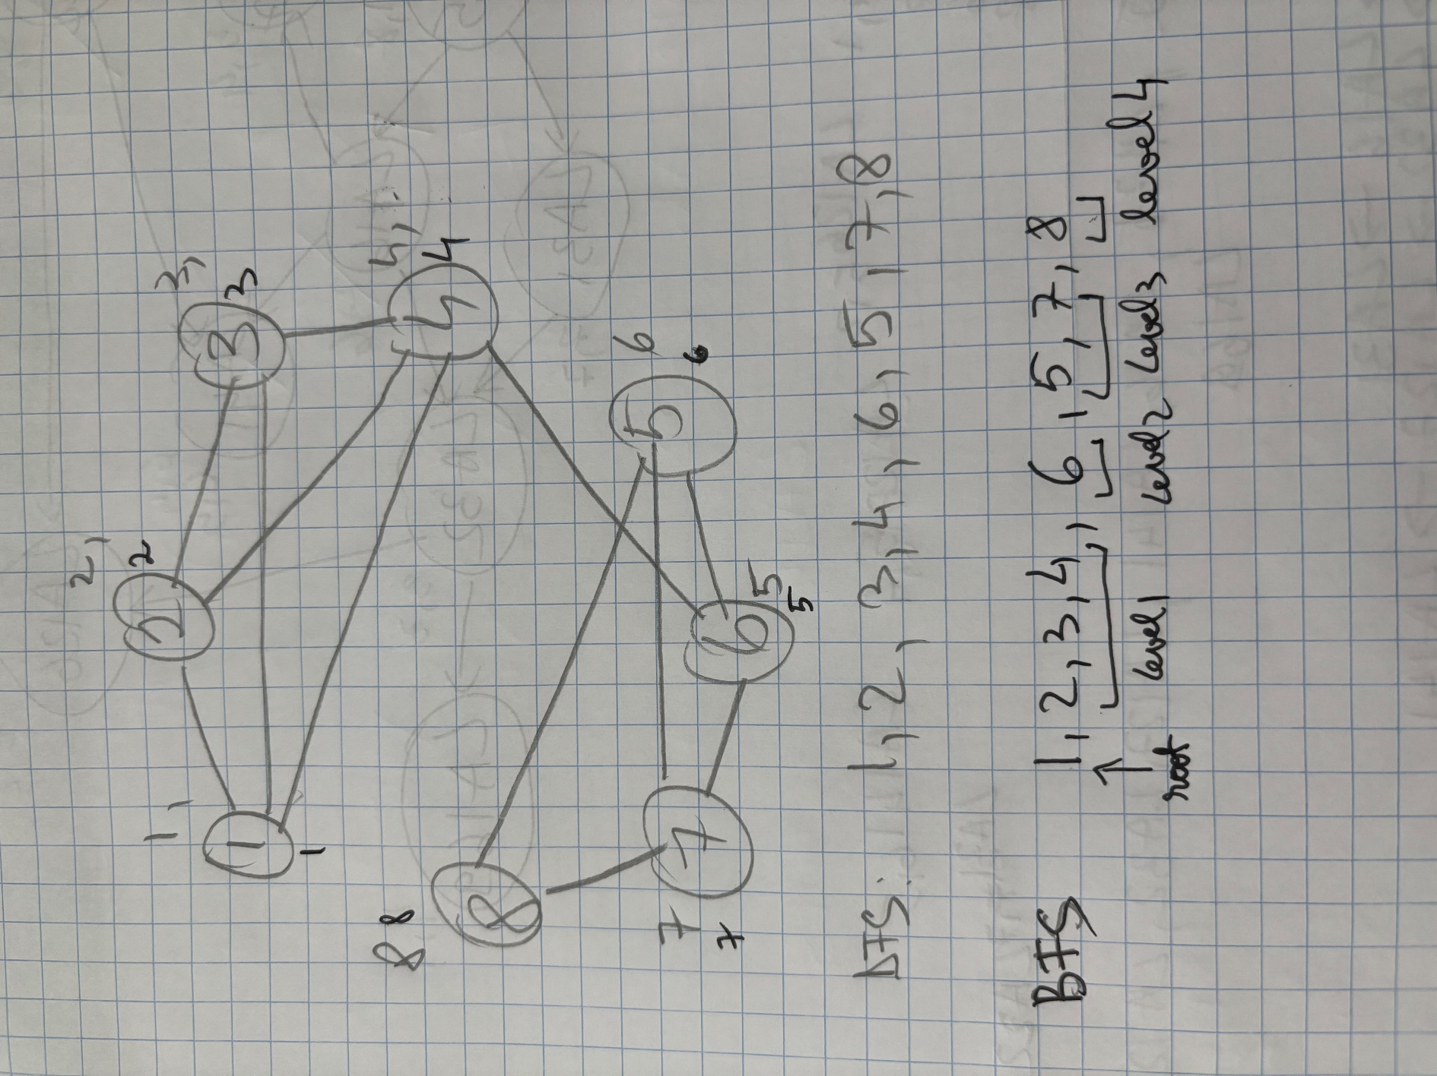

Would you use the adjacency list structure or the adjacency matrix structure in each of the following cases? Justify your choice.
- The graph has 10,000 vertices and 20,000 edges, and it is important to use as little space as possible.
- The graph has 10,000 vertices and 20,000,000 edges, and it is important to use as little space as possible.
- You need to answer the query areAdjacent as fast as possible, no matter how much space you use.

- The adjacency list structure is preferable. Indeed, the adjacency matrix structure wastes a lot of space. It allocates entries for 100,000,000 edges while the graph has only 20,000 edges.
- In general, both structures work well in this case. Regarding the space requirement, there is no clear winner. Note that the exact space usage of the two structures depends on the implementation details. The adjacency matrix structure is much better for operation areAdjacent, while the adjacency list structure is much better for operations insertVertex and re-moveVertex.
- The adjacency matrix structure is preferable. Indeed, it supports operation areAdjacent in O(1) time, irrespectively of the number of vertices or edges.

- Give the order in which the edges are labeled by the DFS traversal shown in Figure 16.3.1.
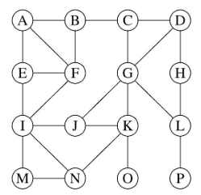
A1,16 B2,15 C3,14 D4,13 G5,12 J6,8 I7,7 E8,2 F9,1 M10,6 N11,5 K12,4 O13,3 L14,11 H15,9 P16, 10

- : Figure 16.4.1: Example of breadth-first search traversal, where the edges incident to a vertex are considered in alphabetical order of the adjacent vertices. The tree edges are shown with solid lines and the nontree (cross) edges are shown with dashed lines.
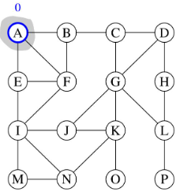
A1, B2, E3, F4, C5, I6, D7, G8, J9, M10, N11, H12, K13, L14, O15, P16

- : Give the order in which the edges are labeled by the DFS traversal shown in Figure 16.3.2.
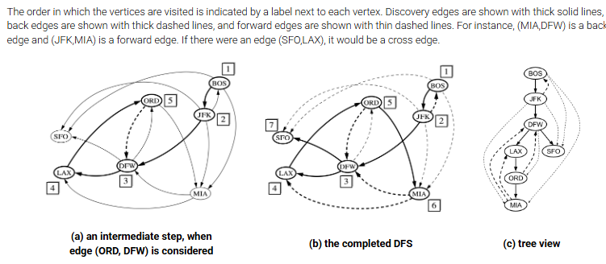

BOS1,7 JFK2,6 DFW3,5 LAX4,3 ORD5,2 MIA6,1 SFO7,4

